Title of Presentation (Times Roman 18, Bold)
Line 2 of Title
A.N. Other¹, B.N. Other² and C.N. Other³ (Times Roman 14 Ital Bold)
¹Organisation 1 (Times Roman 12 Ital, Bold)
²Organisation 2
³Organisation 3

lead.author@organisation.co.uk

Abstracts must be no longer than one page, using a typeface of at least 12 pt. They may include one graphical illustration of key results (optional). Abstracts should outline the research rationale, methodology, results, and key conclusions, with a 300-word count limit.

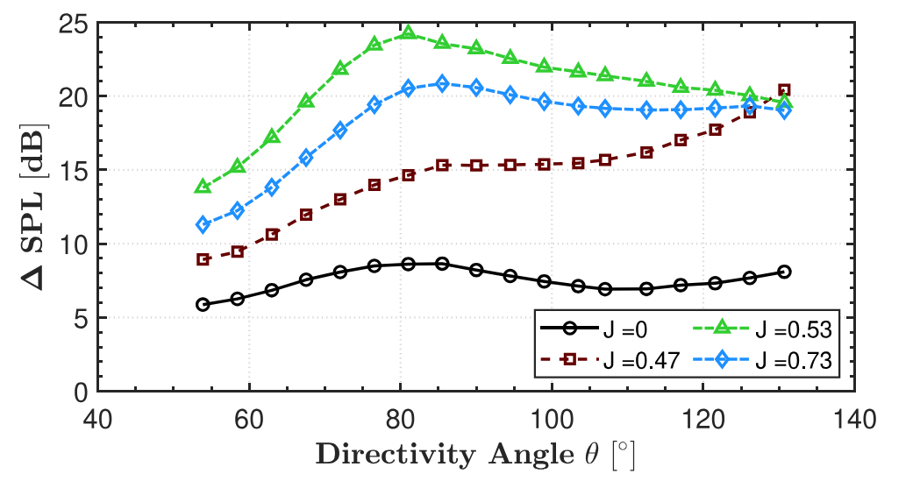
Fig. 1: The directivity of $ΔSPL$ for various advance ratios $0≤J≤0.73$

